**Design Project #1: Introduction to Design and Design Factors**

Daniel J. Brownell, Laurence Souffrant and Jeffrey Ryu

College of Engineering and Computer Science, Syracuse University

MEE 332 Machine Design

February 26, 2021

**Introduction**

The 1st design project required the team to calculate and investigate the distribution of safety factor and design factor within the given range of parameters regarding a situation where a load of constant mass was being suspended by three cables of different lengths. Knowledge obtained from previous courses: statics, solid mechanics, and computational methods was utilized in developing the mathematical models and formulating the MATLAB code.

**Procedure**

The team was required to analyze the effects of combination of parameters upon the distance between a hanging mass supported by three cables made of 2024 annealed aluminum and the ceiling. The initial configuration of the mass and the cables are shown in Figure 1,

where $x_{1}=3.2 m$, $x_{2}=2.7m$, $y_{1}=4.0m$, $y_{2}=3.6m$. Different masses of the crate ($m_{1}=1,000kg$, $m_{2}=2,000kg$), and different diameters of the cables ( $d_{1}=10mm$ to $d_{2}=30mm$) are given. Assumptions were made to facilitate the analysis; the configuration is in static equilibrium and there are no deformations. With the provided parameters, the first objective was to set up a mathematical model that could be coded into a computational method such as MATLAB. In this case, a force balance was employed to convert the equation of tension in cables $AB$, $AC$, and $AD$ into variables that can be used for another equation in calculating the diameters necessary to support the mass with the provided safety factor of 3. The necessary material property of 2024 annealed aluminum in analyzing for the project is ultimate tensile strength of 469 MPa (MatWeb, AA; Typical) and it is are necessary in analyzing the safety factor, tensions, and diameter of the cables.

The necessary equations utilized:

Maximum Allowable Stress (UTS: Ultimate Tensile Strength, SF: Safety Factor)

$σ_{max}=\frac{UTS}{SF}$

Cross-sectional area of cables

$A_{c}={\frac{π*d^{2}}{4}}/{{1000}^{2}} (m^{2})$

Lengths of cables $L_{AB}=\sqrt{{x_{2}}^{2}+{y_{2}}^{2}+z^{2}} (m)$

$$L_{AC}=\sqrt{{x_{1}}^{2}+z^{2}} (m)$$

$L_{AD}=\sqrt{{x_{2}}^{2}+{y_{1}}^{2}+z^{2}} (m)$

Tensile Stresses $σ_{AB}=\frac{T_{AB}}{A_{c}}$

$σ_{AC}=\frac{T_{AC}}{A_{c}}$

$σ_{AD}=\frac{T_{AD}}{A_{c}}$

Tensions $\left[\begin{matrix}\frac{{-x}_{2}}{L_{AB}} & \frac{x_{1}}{L_{AC}} & \frac{{-x}_{2}}{L_{AD}} \\ \frac{{-y}_{2}}{L_{AB}} & 0 & \frac{y_{1}}{L_{AD}} \\ \frac{-z}{L_{AB}} & \frac{-z}{L_{AB}} & \frac{-z}{L_{AD}}\end{matrix}\right]\left[\begin{matrix}T_{AB} \\ T_{AC} \\ T_{AD}\end{matrix}\right]=\left[\begin{matrix}0 \\ 0 \\ -m*g\end{matrix}\right]$

**Code Description**

The computational analysis was performed using MATLAB to plot and visualize the relationship between the tensile stress in each cable and the distance from ceiling. The MATLAB code was written to produce six plots that describe the forementioned relationship for two masses 1000kg and 2000 kg, and diameter of cables varying from 10mm, 20mm, and 30mm. The code was written to be modified with ease, should the team need more plots for smaller increments of variables or swap the variables to a different range and values. A horizontal line will be drawn on the plot to indicate the maximum allowable tensile stress. Stress values of each cable that reside under the cut-off will have a safety factor of 3 or higher.

The results show that for cable diameters 10mm, 20mm and 30mm to maintain a safety factor of three or above, the cables must not support a tensile stress less than 1.5633e+08 Pa. Due to the orientation of cable AD, it will undergo with the most tensile stress and become the first cable to fail. Using 10mm diameters cables will cause the safety factor for cable AD to fall below three at distance shorter than 1.013m and 2.174m for 1000kg and 2000kg masses. When using 20 mm diameter cables, failure to maintain safety factor above three will occur shorter than 0.258m and 0.498m for 1000kg and 2000kg masses, and shorter than 0.118m and 0.228m for 1000kg and 2000kg masses when 30mm diameter cables are used. The data suggest that wider diameters allow the mass to be suspended closer to the ceiling.

The closest position to the ceiling that would accommodate for a safety factor of three is 0.130m as seen in the “z vs SF” graph. This data demonstrates that the highest safety factor is achieved when selecting the largest diameter available (30mm) and the lightest mass (1000kg). This graph further showcases that the minimum diameter for the cables to maintain a safety factor of three is 10mm. While using 10 mm diameter cables, 1000kg and 2000kg masses can lift as close as 1.257m and 3.431m from the ceiling to maintain a safety factor of three.

**Anticipated Result**

The team anticipated that as the diameter increases, the distance from the ceiling for the system to maintain an overall safety factor of 3 will decrease. As the distance between the ceiling and the mass increases, the tensile stress within the cables is predicted to decrease, increasing the Safety Factor as a result. It is expected that cable AB would have the greatest stress due to its base being the closest to the mass, aligning the most approximately to the vertical distance between the mass and the ceiling.

**Results**

The following is from a published code of MATLAB that investigates how the different masses of 1000kg and 2000kg and varying diameters 10mm, 20mm, and 30mm influence the tensile stresses within cables AB, AC, and AD. The results mostly aligned with the team’s initial approximation, with the tensile stress being the greatest in the cable AC. To determine the safety factor relative to the distance between the ceiling and the mass, tensile stress of cable AC was selected because it consistently showed the greatest tensile stress among the three cables for different variables. The first six figures plot the relationship between the distance from ceiling and the tensile stress in the cables and the dotted horizontal line indicates the maximum allowable strength according to safety factor of three. Any value above the dotted line would result in a design with safety factor less than three, and below would result in a design above safety factor of three. The seventh figure shows a plot of how the safety factor variates with different masses and diameters, and it was calculated with the tensile stress of cable AC. The plots align with the anticipated results, showing that the tensile stresses increasing as the mass gets closer to the ceiling, decreasing the safety factor as a result. While the ultimate tensile strength remains constant for 2024 annealed aluminum, the stress exerted on the three cables increases, causing this outcome.

**Conclusion**

In conclusion, it is observed that a lighter mass, larger diameter, and further ceiling- mass distance would create a safer design due to smaller tensile stress within the cables. Since the cable AC consistently had the greatest tensile stress, a design focused on cable AC would be necessary to follow an appropriate safety factor. In a case where $x_{1},x_{2},y_{1},$ and $y_{2}$ can be variated, it will create a need to change the calculation of safety factor and tensile stresses, because the length of cables would change and cable AC could not be the one with the greatest tensile stress. In another case where the diameters are different for each cable, the cable with the smallest diameter will have the greatest tensile stress; i.e., making it the weakest cable that needs to be considered when calculating the safety factor.

All in all, utilizing the static equilibrium and computational techniques, the team was able to analyze the stresses in the design and predict the change of safety factor and forces relative to the change in ceiling-mass distance, diameter, and mass. The analysis concludes that within the presented sets of variables, 6m below the ceiling, 30mm diameter cables, and 1000kg mass result in the least tensile stresses in the cable and the highest safety factor, thus making it the optimal design for safety.

**References**

MatWeb. Aluminum 2024-T4; 2024-T351 Datasheet

http://www.matweb.com/search/datasheet_print.aspx?matguid=67d8cd7c00a04ba29b618484f7ff7524

**Figures**

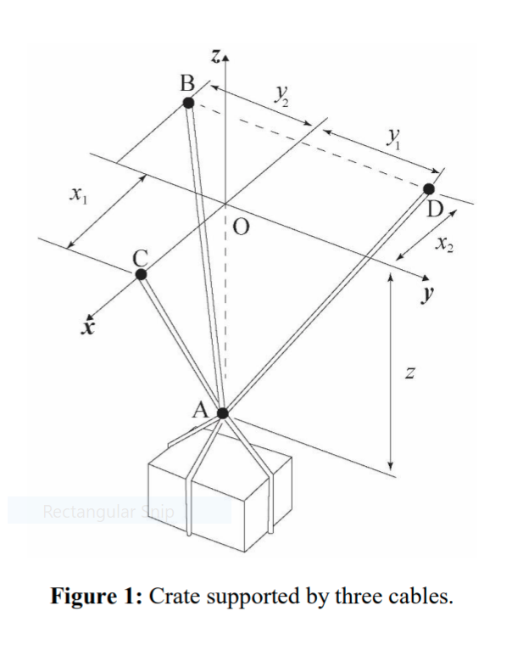

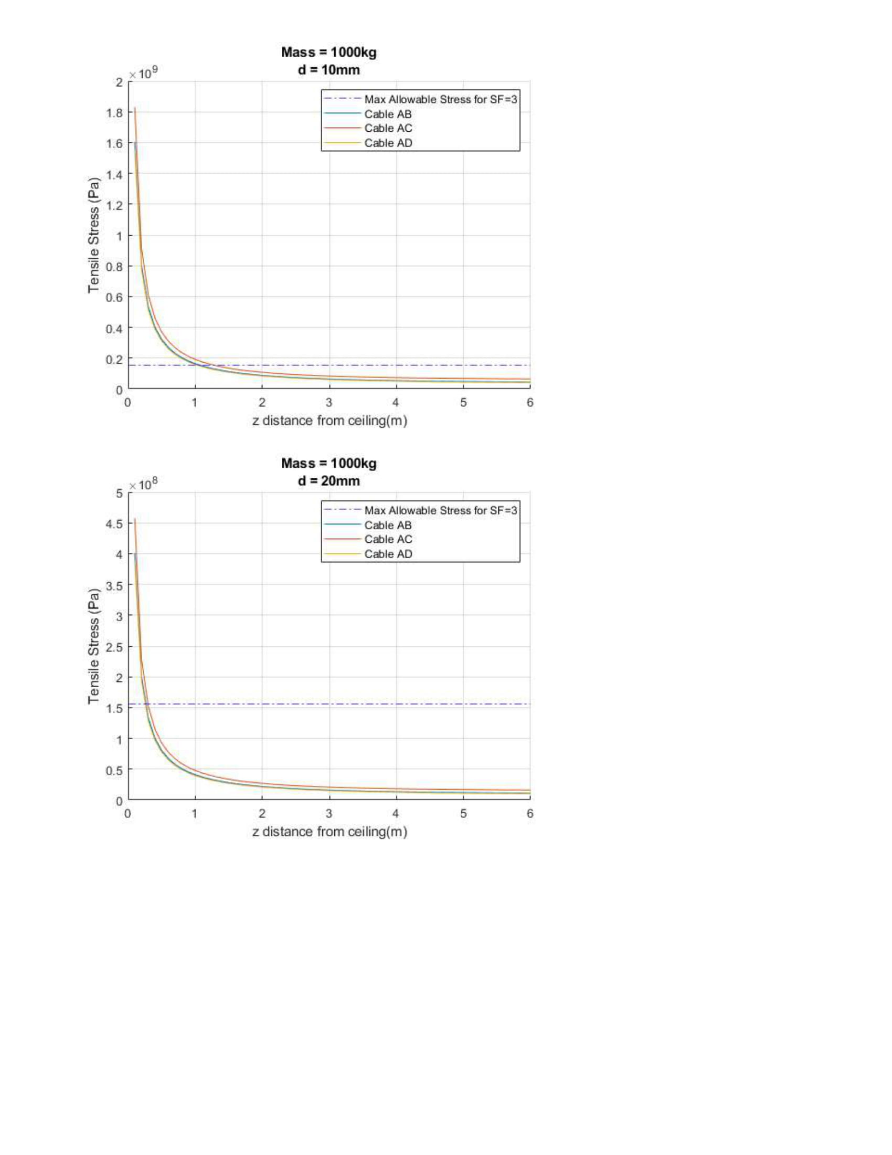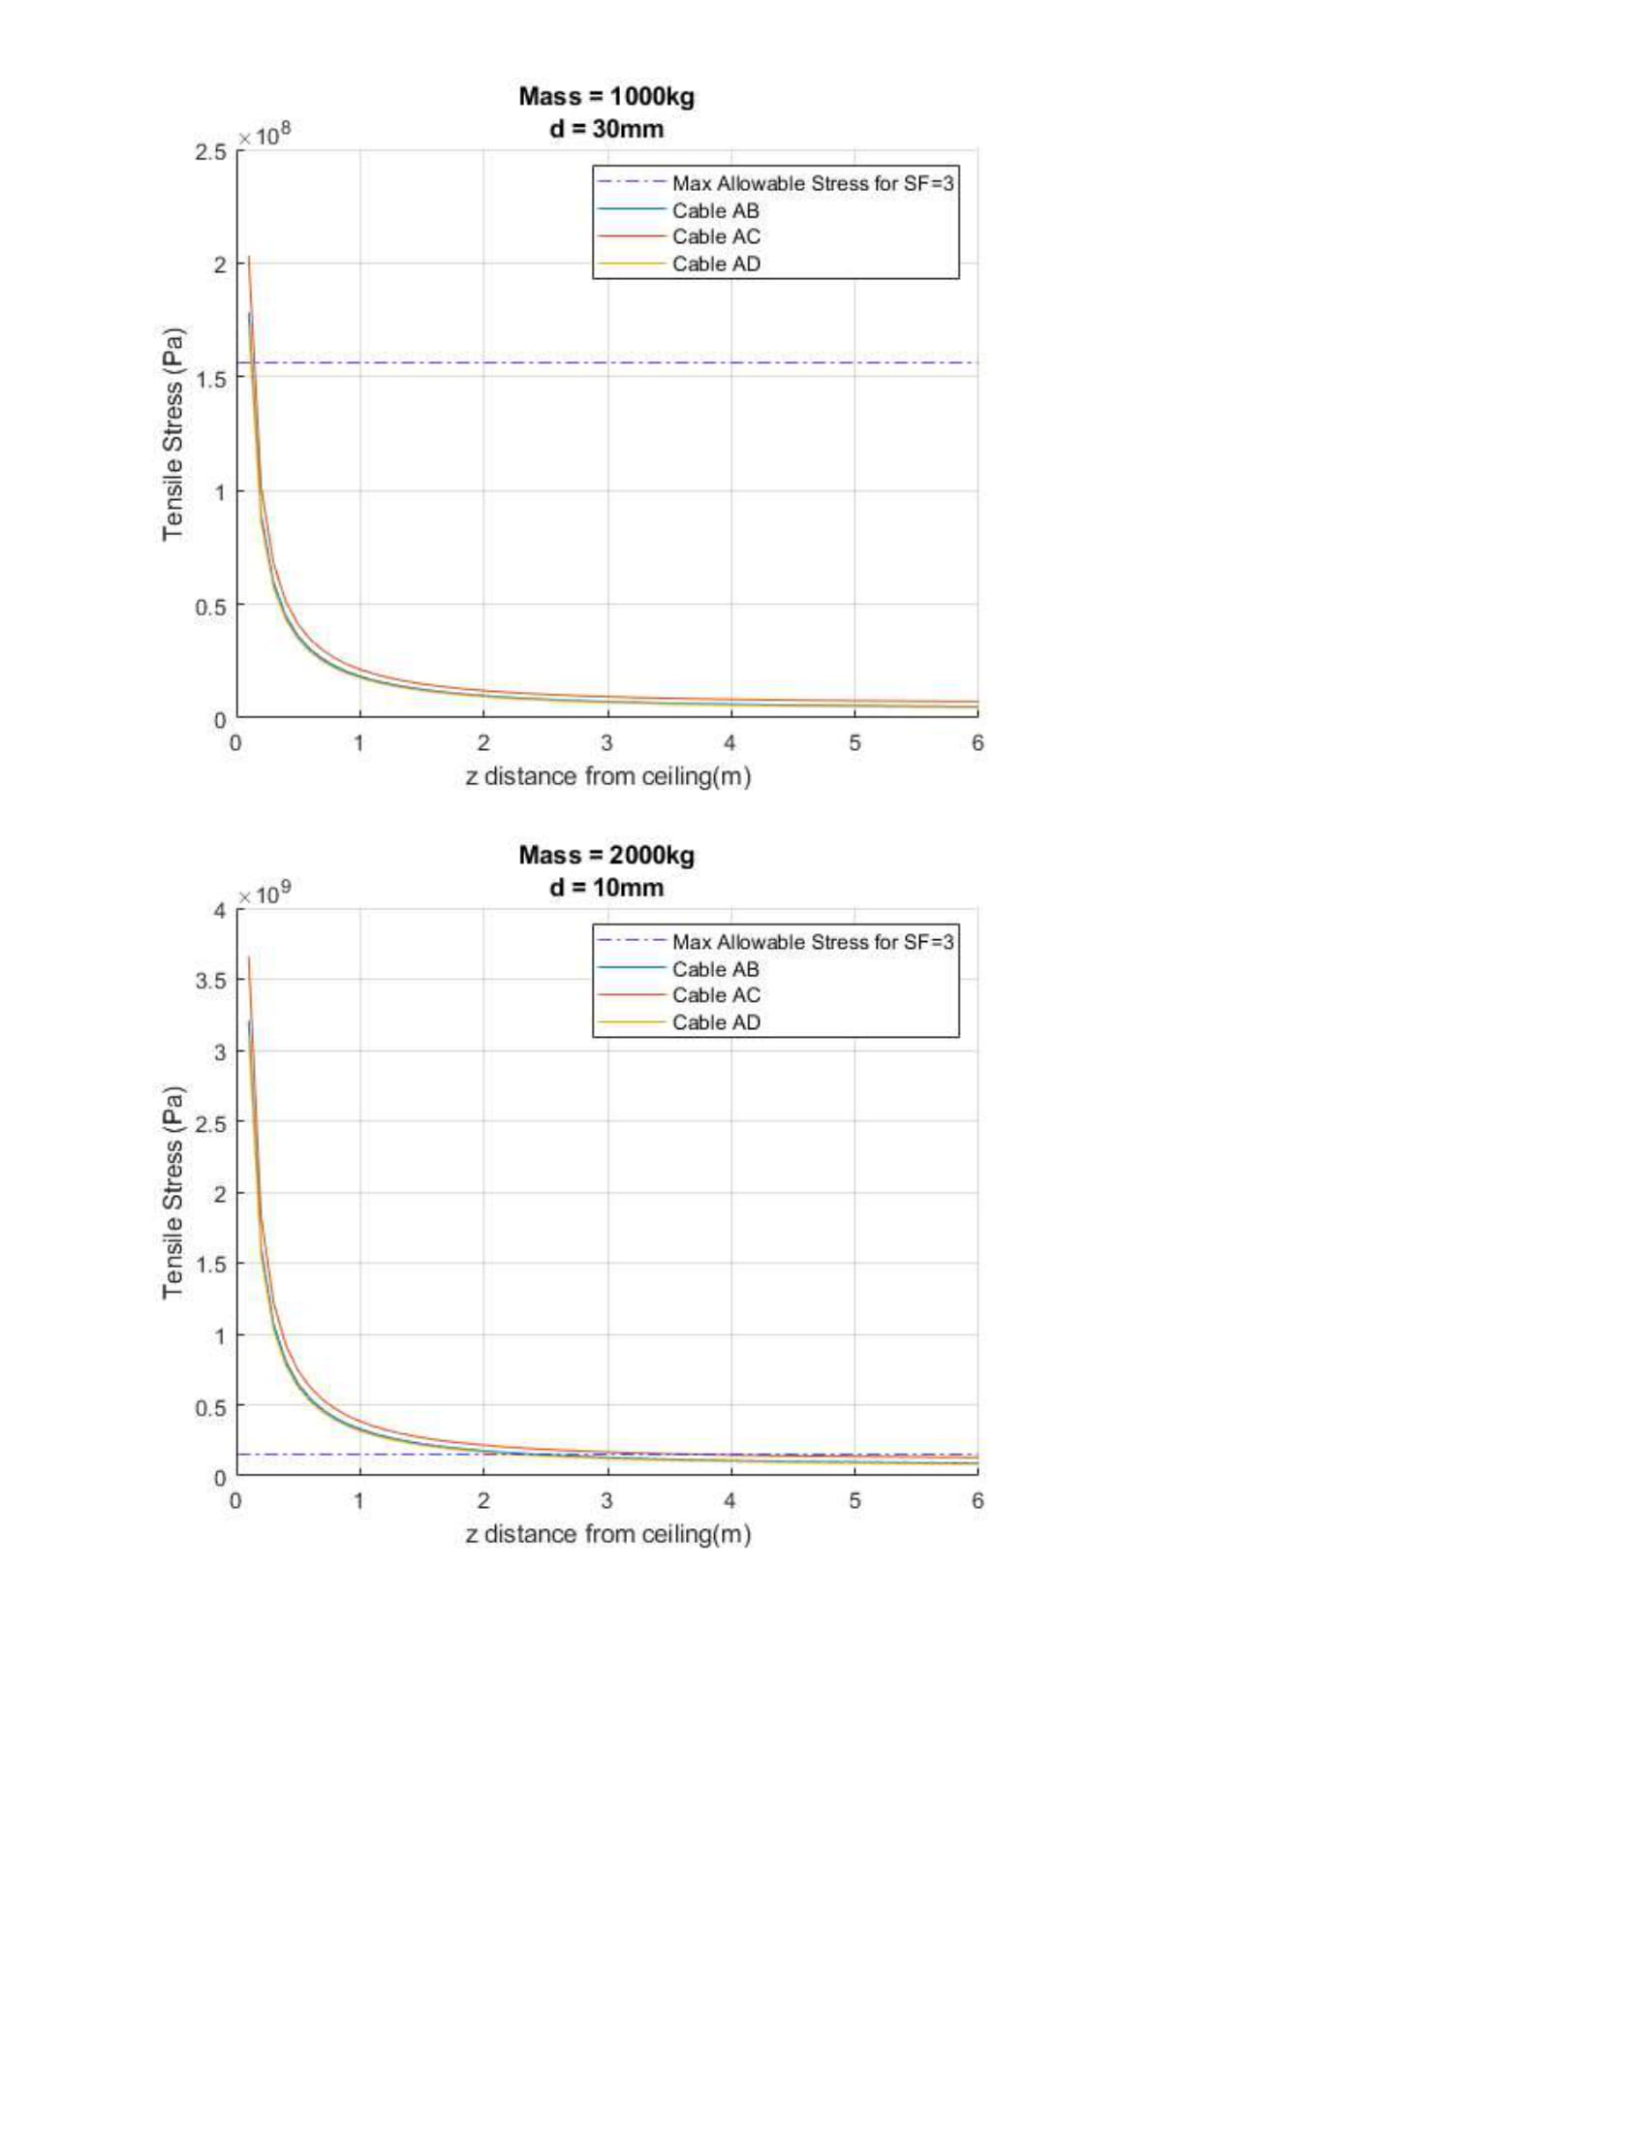

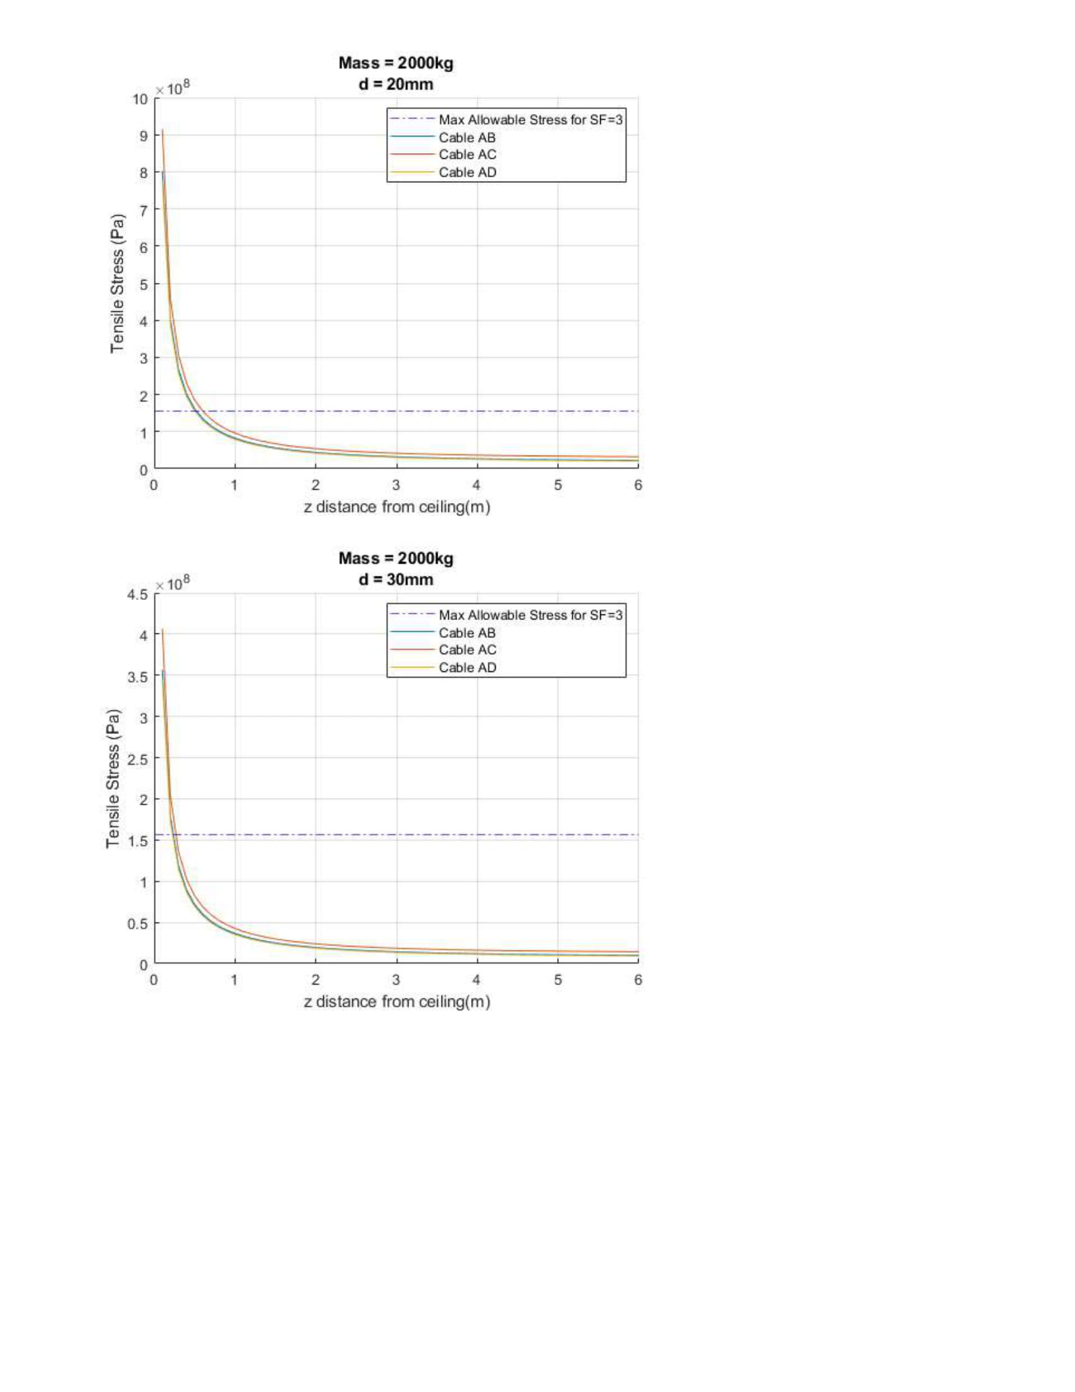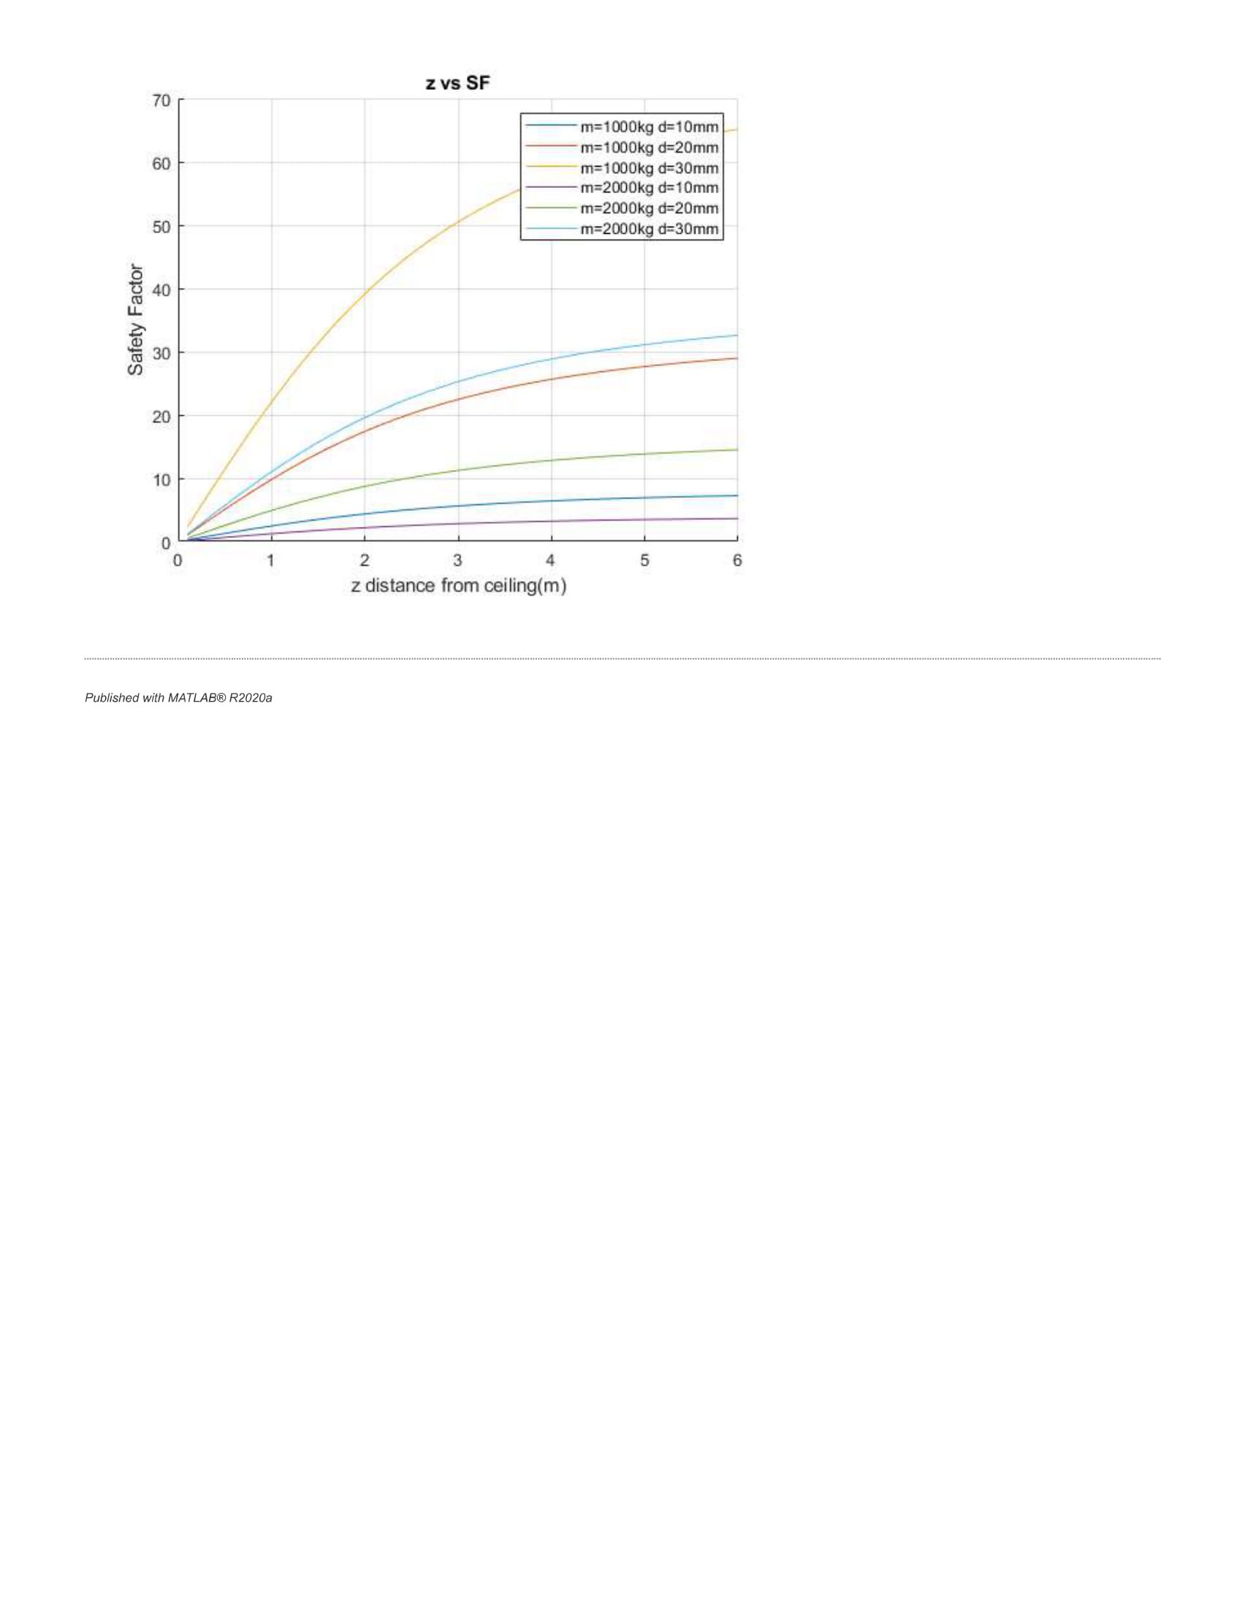

**Appendix**

